Classification of Insurance claims – Fraud detection using machine learning

# 

# Problem Definition:-

The goal of this project is to build a model that can detect auto insurance fraud. The challenge behind fraud detection in machine learning is that frauds are far less common as compare to legit insurance claims.

Insurance fraud detection is a challenging problem, given the variety of fraud patterns and relatively small ratio of known frauds in typical samples. While building detection models, the savings from loss prevention needs to be balanced with cost of false alert. Machine learning technique allow for improving predictive accuracy, enabling loss control units to achieve higher coverage with low false positive rates.

Insurance frauds cover the range of improper activities which an individual may commit in order to achieve a favorable outcome from the insurance company. This could range from staging the incident, misrepresenting the situation including the relevant actors and the cause of incident and finally the extent of damage caused.

## Data Analysis:-

In this project, we have a dataset which has the details of the insurance policy along with the customer details. It also has the details of the accident on the basis of which the claims have been made.

The given dataset contains 1000 rows and 40 columns. The column names like policy number, policy bind date, policy annual premium, incident severity, incident location, auto model, etc.

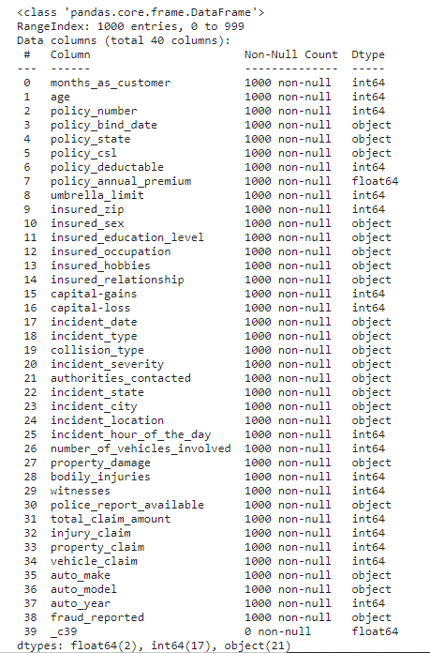

The obvious con of this data set is the small sample size. However, there are still many companies who do not have big data sets. The ability to work with what is available is crucial for any company looking to transition into leveraging data science.

Compared to a company that waits for the day when it has a huge data set, the company that started with a small data set and worked on it will more likely succeed earlier in its data science journey and reap its rewards.

There are some variable which contains the null values character ‘?’. The number of null values present is given below.

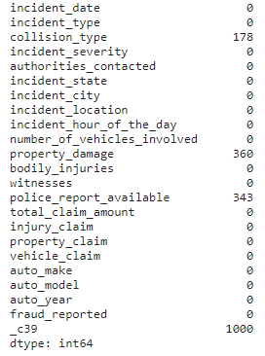

The column collision_type, property damage, police_report_available, _c39 contains 178, 360, 343, 1000 null values.

### Exploratory data analysis:-

* Dependent variable

Exploratory data analysis was conducted started with the dependent variable, Fraud_reported. There were 247 frauds and 753 non-frauds. 24.7% of the data were frauds while 75.3% were non-fraudulent claims.

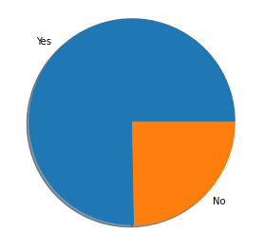 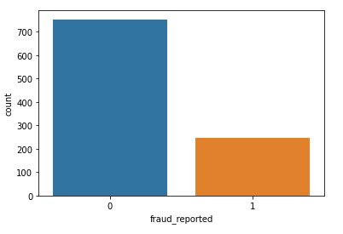

* Correlations among variables

Heatmap was plotted for variables with at least 0.3 Pearson’s correlation coefficient, including the DV.

Month as customer and age had a correlation of 0.92. Probably because drivers buy auto insurance when they own a car and this time measure only increases with age.

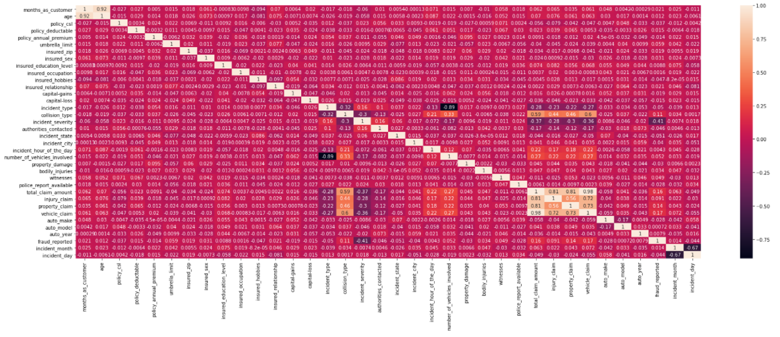

Apart from that, there don’t seem to be much correlations in the data.

There don’t seem to be multicollinearity problem except maybe that all the claims are all correlated, and somehow total claims have accounted for them.  
However, the other claims provide some granularity that will not otherwise be captured by total claims. Thus, these variables were kept.

* Visualizing variables

The value of fraud reported are differed across hobbies of the customer.

It seems like chess players and cross-fitters have higher tendencies to fraud.

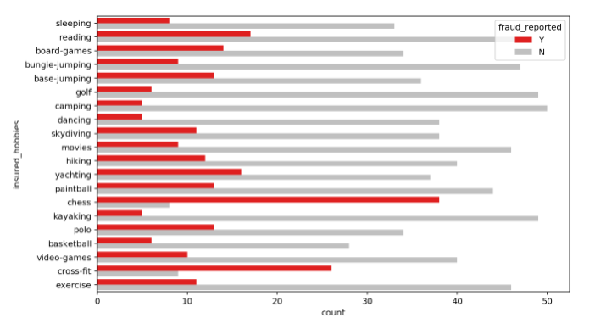

Major incidents severity seems to have highest fraud cases that exceeds non fraud cases.

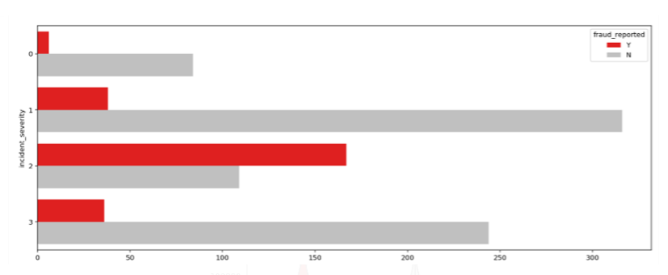

The total_claim_amount is high in audi auto_make.

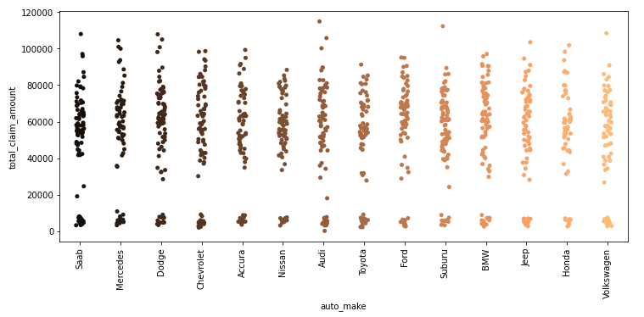

Injury_claim found highest in the Nissan.

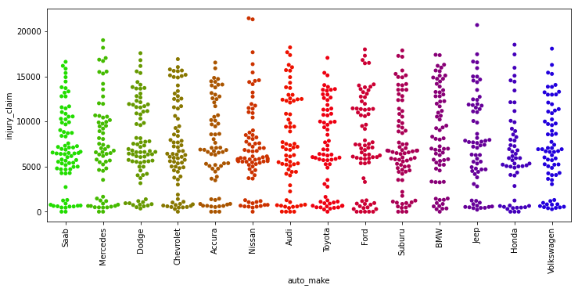

Checking correlation between dependent and independent variable.

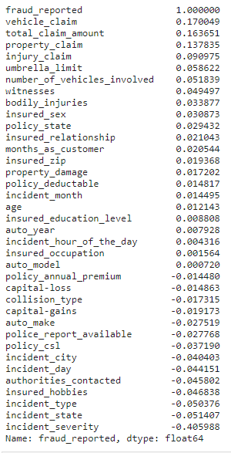

#### Pre processing Pipeline:-

Data preprocessing is a predominant step in machine learning to yield highly accurate and insightful results. Greater the quality of data, the greater is the reliability of the produced results. **Incomplete, noisy, and inconsistent data** are the inherent nature of real-world datasets. Data preprocessing helps in increasing the quality of data by filling in missing incomplete data, smoothing noise, and resolving inconsistencies.

* **Incomplete data** can occur due to many reasons. Appropriate data may not be persisted due to a misunderstanding, or because of instrument defects and misfunctions.
* **Noisy data** can occur for a number of reasons (having incorrect feature values). The instruments used for the data collection might be faulty. Data entry may contain human or instrument errors. Data transmission errors might occur as well.

There are many stages involved in data preprocessing.

* **Data cleaning** attempts to impute missing values, removing outliers.
* **Data integration** integrates data from a multitude if source into single data warehouse.
* **Data transformation** such as normalization, may be applied. For example, normalization may improve the accuracy and efficiency of mining algorithms involving distance measurement.
* **Data reduction** can reduce the data size by dropping out redundant features. Feature selection and feature extraction technique can be used.

**Treating null values** sometimes there are certain columns which contain the null value use to indicating missing or unknown values or may be the value doesn’t exist.

In our dataset the null values is present in columns collision_type, property_damage, police_report_available, and _c39 with 178, 360, 343 and 1000 number of null values.

There are different ways of replacing null values from the dataset, but we are using fillna to replace the null values from our data.

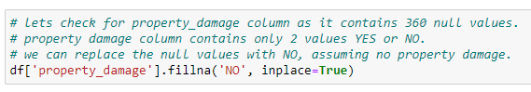

**Converting labels into numeric:**

In machine learning, we usually deal with datasets which contains multiple labels in one or more than one columns. These labels can be in the form of words or numbers. To make the data understandable or in human readable form, the training data is often labeled in words.

In our data there are columns with categorical values. The columns like incident_severity, incident_state, incident_type, insured_hobbies, authorities_contacted, incident_city, police_report_available, auto_make, collision_type, auto_model, insured_occupation, insured_education_level, property_damage, insured_relationship, policy_state, insured_sex, fraud_reported. These columns have to be treated with one hot encoding or the label encoder. The target variable fraud_reported have to covert by using label encoder only.

**Label Encoder** refers to converting the labels into numeric form so as to convert it into the machine readable form. Machine learning algorithms can then decide in a better way on how those labels must be operated. It is an important pre-processing step for the structured dataset in supervised learning.

Label encoding in python can be imported from Sklearn library. Sklearn provides very efficient tool for encoding. Label encoder encode labels with a value between 0 and n_classes-1.

Taking an example from our dataset.

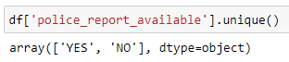

After applying label encoder.

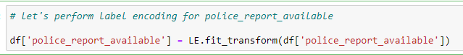

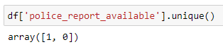

**Outliers** An outlier is a data point that is distant from other similar points. They may be due to variability in the measurement or may indicate experimental errors. If possible, outliers should be excluded from the data set. However, detecting that anomalous instance might be very difficult, and is not always possible.

Methods to remove outliers:

Z-score:- Call scipy.stats.zscore() with the given dataframe as its argument to get a numpy array containing the z-score of each value in a dataframe. Call numpy.abs() with the previous result to convert each element in dataframe to its absolute value. Use the syntax (array<3).all(axis=1) with array as the previous result to create a boolean array.

Inter-quartile range:- The inter-quartile range can be used to detect the outliers present in the dataframe.

1. Calculate the inter-quartile range for the data by using scipy.stats.iqr module.
2. Multiply the inter-quartile range by 1.5.
3. Add 1.5 x inter-quartile range to the third quartile. Any number greater than this is a suspected outlier.
4. Subtract 1.5 x inter-quartile range from the first quartile. Any number lesser than this is a suspected outlier.

**Balancing our imbalanced data**:- There are different algorithms present to balance the target variable. We use the SMOTE() algorithm to make our data balance.

**What is SMOTE:-** SMOTE(Synthetic minority oversampling technique) works by randomly picking a point from the minority class and computing the k-nearest neighbors of this point. The synthetic points are added between the chosen point and its neighbors.

SMOTE algorithm works in 4 simple steps:-

1. Choose a minority class as input vector.
2. Find its k-nearest neighbors.
3. Choose one of these neighbors and place a synthetic point anywhere on the line joining the point under consideration and its chosen neighbors.
4. Repeat the step until the data is balanced.

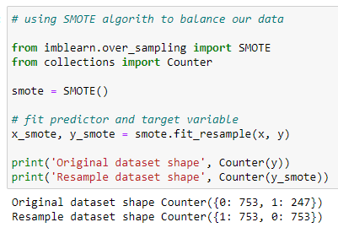

The original shape of our data was 753 for fraud_reported with NO value and 247 for YES.

The SMOTE algorithm balance our data with the highest number of values present in it.

##### Building machine learning models:

For building machine learning model there are several models present inside the Sklearn module.

Sklearn provides two types of models i.e. regression and classification. Our dataset’s target variable is to predict whether fraud reported or not. So for this kind of problem we use classification models.

But before fitting our dataset to its model first we have to separate the predictor variable and the target variable, then we pass this variable to the train_test_split method to create random test and train subset.

**What is train_test_split** is a function in sklearn model selection for splitting data arrays into two subsets for training data and testing data. With this function, you don’t need to divide dataset manually. By default, sklearn train_test_split will make random partitions for the two subsets. However, you can also specify a random state for the operation. It gives four output x_train, x_test, y_train and y_test. The x_train and x_test contains the training and testing predictor variables while y_train and y_test contains the training and testing target variable.

After performing train_test_split we have to choose the models to pass the training variable.

We can build as many models as we want to compare the accuracy given by these models and to select best model among them.

I have selected 5 models:-

1. Logistic Regression from sklearn.linear_model:- Logistic regression is a supervised learning classification algorithm used to predict the probability of a target variable. The nature of target or dependent variable is binary, which means there would be only two possible classes 1 (stands for success/yes) or 0 (stands for failure/no). Mathematically, a logistic regression model predicts P(Y=1) as a function of X. It is one of the simplest ML algorithms that can be used for various classification problems such as spam detection, Diabetes prediction, cancer detection etc.

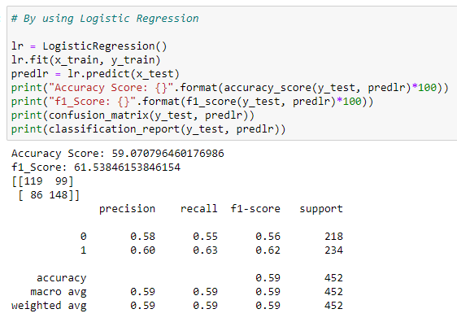

1. GaussianNB from sklearn.naive_bayes:- Naive Bayes algorithms are a classification technique based on applying Bayes’ theorem with a strong assumption that all the predictors are independent to each other. In simple words, the assumption is that the presence of a feature in a class is independent to the presence of any other feature in the same class. It is the simplest Naïve Bayes classifier having the assumption that the data from each label is drawn from a simple Gaussian distribution.

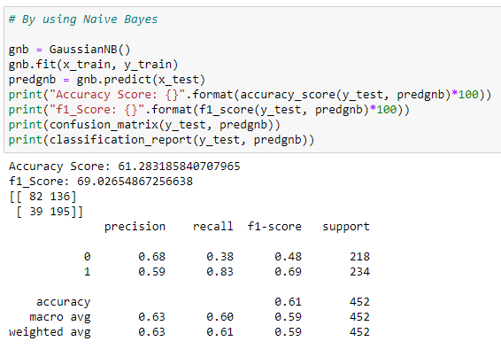

1. KNeighborsClassifiers from sklearn.neighbors:- K-nearest neighbors (KNN) algorithm uses ‘feature similarity’ to predict the values of new data points which further means that the new data point will be assigned a value based on how closely it matches the points in the training set.

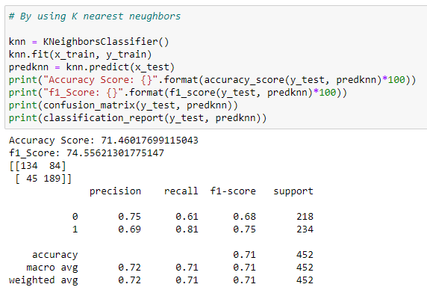

1. DecisionTreeClassifier from sklearn.tree:- Decision trees can be constructed by an algorithmic approach that can split the dataset in different ways based on different conditions. The two main entities of a tree are decision nodes, where the data is split and leaves, where we got outcome.

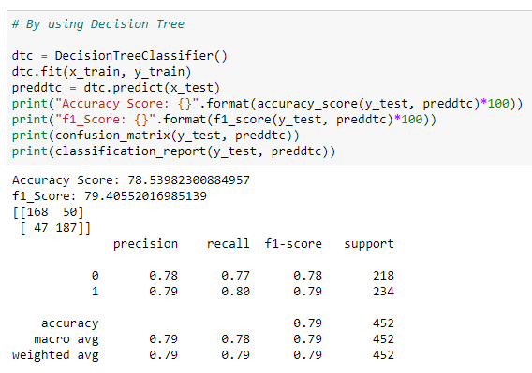

1. RandomForestClassifier from sklearn.ensemble:- As we know that a forest is made up of trees and more trees means more robust forest. Similarly, random forest algorithm creates decision trees on data samples and then gets the prediction from each of them and finally selects the best solution by means of voting. It is an ensemble method which is better than a single decision tree because it reduces the over-fitting by averaging the result.

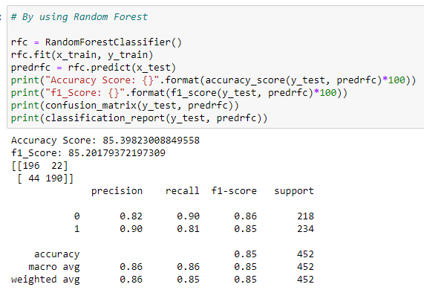

**Conclusion:**

We got our best model i.e. RandomForestClassifier with the accuracy score of 85.39%.

Here our model predicts 196 true positive cases out of 218 positive cases and 190 true negative cases out of 234 cases.

It predicts 22 false positive cases out of 218 positive cases and 44 false negative cases out of 234 cases.

It gives the f1 score of 85.20%.

**Let’s understand what does precision recall and f1 score and accuracy means.**

* **F1 score**: this is the harmonic mean of precision and recall and gives a better measure of the incorrectly classified cases than the accuracy matrix.

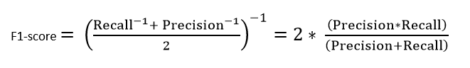

* **Precision:** It is implied as the measure of the correctly identified positive cases from all the predicted positive cases. Thus, it is useful when the costs of False Positives are high.

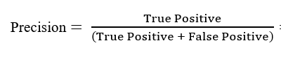

* **Recall:** It is the measure of the correctly identified positive cases from all the actual positive cases. It is important when the cost of False Negatives is high.

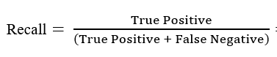

* **Accuracy:** One of the more obvious metrics, it is the measure of all the correctly identified cases. It is most used when all the classes are equally important.

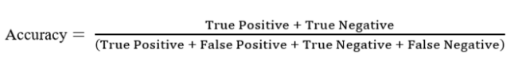

**Let’s understand what confusion matrix is:**

A confusion matrix is a table that is often used to describe the performance of a classification model (or ‘classifier’) on a set of test data for which the true values are known.

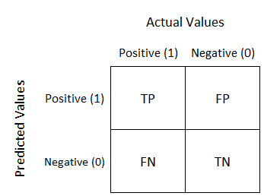

1. **TN/True Negative:** the cases were negative and predicted negative.
2. **TP/True Positive:** the cases were positive and predicted positive.
3. **FN/False Negative:** the cases were positive but predicted negative.
4. **TN/True Negative:** the cases were negative but predicted positive.

**Hyper parameter tuning:**

Hyper parameter optimization in machine learning intends to find the hyper parameters of a given machine learning algorithm that deliver the best performance as measured on a validation set. Hyper parameters, in contrast to model parameters, are set by the machine learning engineer before training. The number of trees in a random forest is a hyper parameter while the weights in a neural network are model parameters learned during training. I like to think of hyper parameters as the model settings to be tuned so that the model can optimally solve the machine learning problem.

We will use GridSearchCV for the hyper parameter tuning.

**GridSearchCV:** In GridSearchCV approach, machine learning model is evaluated for a range of hyper parameter values. This approach is called GridSearchCV, because it searches for best set of hyper parameters from a grid of hyper parameters values.

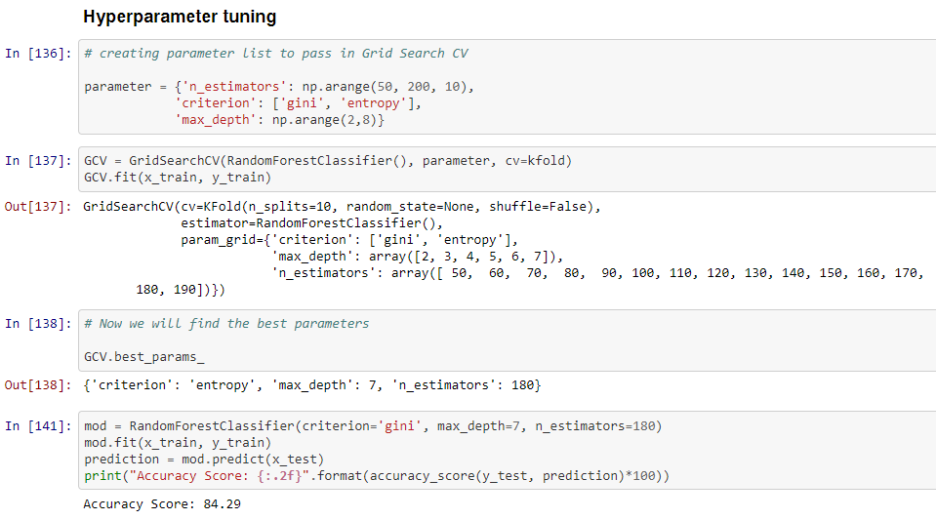

**Plotting ROC curve:**

AUC - ROC curve is a performance measurement for the classification problems at various threshold settings. ROC is a probability curve and AUC represents the degree or measure of separability. It tells how much the model is capable of distinguishing between classes. Higher the AUC, the better the model is at predicting 0s as 0s and 1s as 1s. By analogy, the Higher the AUC, the better the model is at distinguishing between patients with the disease and no disease.

The ROC curve is plotted with TPR against the FPR where TPR is on the y-axis and FPR is on the x-axis.

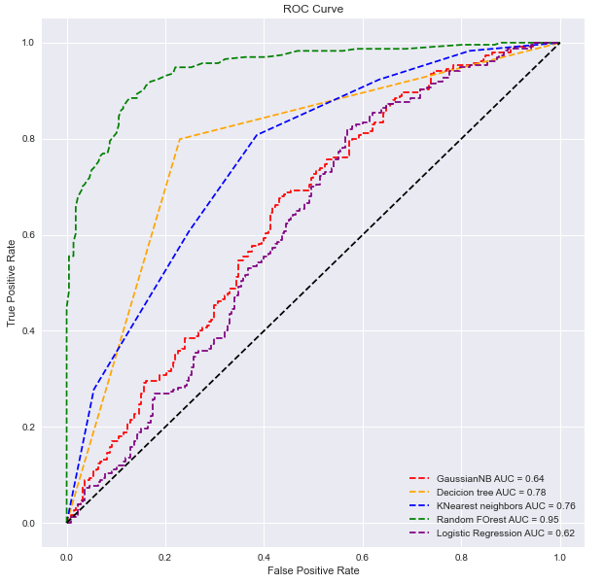

##### Concluding remarks

This project has built a model that can detect auto insurance fraud. In doing so, the model can reduces loses for insurance companies. The challenge behind fraud detection in machine learning is that frauds are far less common as compared to legit insurance claims.

Five different classifiers were used in this project: logistic regression, K-nearest neighbors, Random forest, Decision tree, GaussianNB. Four different ways of handling imbalance classes were tested out with these five classifiers: model with class weighting, oversampling with SMOTE, hyper parameter tuning, and plotting roc curve of the models.

The best and final fitted model was a weighted Random Forest what yelled a F1 score of 0.85 and a ROC AUC of 0.95. The model performed excellent. The model’s F1 score and ROC AUC scores were the highest amongst the other models. In conclusion, the model was able to correctly distinguish between fraud claims and legit claims with high accuracy.

The study is not without limitations. Firstly, this study is restricted by its small sample size. Statistical models are more stable when data sets are larger. It also generalizes better as it takes a bigger proportion of the actual population. Furthermore, the data only capture incident claims of 3 states.

***References:-***

[towardsdatascience.com](https://towardsdatascience.com/)

[kdnuggets.com](https://www.kdnuggets.com/)

medium.com